The Ameba

Kingdom: | Protista
Phylum: | Amoebozoa
Subphylum: | Lobosa
Class: | Tubulinea
Order: | Tubulinida
Family: | Amoebidae
Genus: | Amoeba
Ameba (or Amoeba) are characterized by possessing clear protoplasm which form pseudopodia. These pseudopodia are the means by which these organisms move and engulf bacteria and red blood cells for feeding purposes. The most common amebas seen in the intestinal tract are Entamoeba histolytica/dispar, Entamoeba coli, Entamoeba hartmanni, Endolimax nana and Iodamoeba bütschlii. All but Entamoeba histolytica are thought to be non-pathogenic. Amoebae, like other unicellular eukaryotic organisms, reproduce asexually via mitosis and cytokinesis, not to be confused with binary fission, which is how prokaryotes (bacteria) reproduce. In cases where the amoeba are forcibly divided, the portion that retains the nucleus will survive and form a new cell and cytoplasm, while the other portion dies. Amoebae also have no definite shape. The cysts can be identified in an ethyl acetate concentrate by the addition of iodine to reveal the characteristic inclusions and also by measuring the cyst using an eyepiece graticule. The trophozoites can be seen in a fresh saline preparation of the stool although accurate identification is on a permanently stained fecal smear.
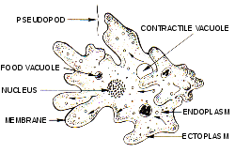

Entamoeba histolytica
Entamoeba histolytica
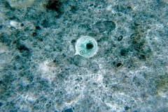
Entamoeba histolytica cyst
Scientific classification
Domain: | Eukaryota
Phylum: | Amoebozoa
Class: | Archamoebae
Order: | Amoebida
Genus: | Entamoeba
Species: | E. histolytica
Binomial name
Entamoeba histolytica
Schaudinn, 1903
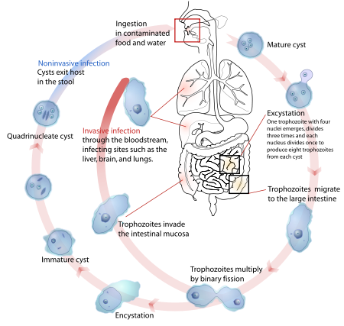
Life-cycle of Entamoeba histolytica
Entamoeba histolytica is an anaerobic parasitic protozoan, part of the genus Entamoeba. Predominantly infecting humans and other primates, E. histolytica is estimated to infect about 50 million people worldwide. Previously, it was thought that 10% of the world population was infected, but these figures predate the recognition that at least 90% of these infections were due to a second species, E. dispar. Mammals such as dogs and cats can become infected transiently, but are not thought to contribute significantly to transmission.

Transmission
The active (trophozoite) stage exists only in the host and in fresh loose feces; cysts survive outside the host in water, in soils, and on foods, especially under moist conditions on the latter. The cysts are readily killed by heat and by freezing temperatures, and survive for only a few months outside of the host.^{[3]} When cysts are swallowed they cause infections by excysting (releasing the trophozoite stage) in the digestive tract. The pathogenic nature of E. histolytica was first reported by Lösch in 1875, but it was not given its Latin name until Fritz Schaudinn described it in 1903. E. histolytica, as its name suggests (histo–lytic = tissue destroying), is pathogenic; infection can be asymptomatic or can lead to amoebic dysentery or amoebic liver abscess.^{[1]} Symptoms can include fulminating dysentery, bloody diarrhea, weight loss, fatigue, abdominal pain, and amoeboma. The amoeba can actually 'bore' into the intestinal wall, causing lesions and intestinal symptoms, and it may reach the blood stream. From there, it can reach different vital organs of the human body, usually the liver, but sometimes the lungs, brain, spleen, etc. A common outcome of this invasion of tissues is a liver abscess, which can be fatal if untreated. Ingested red blood cells are sometimes seen in the amoeba cell cytoplasm.

Diagnosis
It can be diagnosed by stool samples, but it is important to note that certain other species are impossible to distinguish by microscopy alone. Trophozoites may be seen in a fresh fecal smear and cysts in an ordinary stool sample. ELISA or RIA can also be used.

Treatment
There are many kinds of effective drugs. This is just a short overview of a few of the different methods of treatments.
Intestinal infection: Usually nitroimidazole derivatives are used because they are highly effective against the trophozoite form of the amoeba. Since they have little effect on amoeba cysts, usually this treatment is followed by an agent (such as paromomycin or diloxanide furoate) that acts on the organism in the lumen.
Liver abscess: In addition to targeting organisms in solid tissue, primarily with drugs like metronidazole and chloroquine, treatment of liver abscess must include agents that act in the lumen of the intestine (as in the preceding paragraph) to avoid re-invasion. Surgical drainage is usually not necessary except when rupture is imminent. Asymptomatic patients: For asymptomatic patients (otherwise known as carriers, with no symptoms), non endemic areas should be treated by paromomycin, and other treatments include diloxanide furoate and iodoquinol. There have been problems with the use of iodoquinol and iodochlorhydroxyquin, so their use is not recommended. Diloxanide furoate can also be used by mildly symptomatic persons who are just passing cysts.

Genus and species | Entamoeba histolytica
Etiologic agent of: | Amoebiasis; amoebic dysentery; extraintestinal amoebiasis, usually amoebic liver abscess; "anchovy sauce"); amoeba cutis; amoebic lung abscess ("liver-colored sputum")
Infective stage | Tetranucleated cyst (having 4 nuclei)
Definitive host | Human
Portal of entry | Mouth
Mode of transmission | Ingestion of mature cyst through contaminated food or water
Habitat | Colon and cecum
Pathogenic stage | Trophozoite
Locomotive apparatus | Pseudopodia ("false foot”")
Motility | Active, progressive and directional
Nucleus | 'Ring and dot' appearance: peripheral chromatin and central karyosome
Mode of reproduction | Binary fission
Pathogenesis | Lytic necrosis (it looks like “flask-shaped” holes in Gastrointestinal tract sections (GIT)
Type of encystment | Protective and Reproductive
Lab diagnosis | Most common is direct fecal smear (DFS) and staining (but does not allow identification to species level); enzyme immunoassay (EIA); indirect hemagglutination (IHA); Antigen detection – monoclonal antibody; PCR for species identification. Sometimes only the use of a fixative (formalin) is effective in detecting cysts. Culture: From faecal samples - Robinson's medium, Jones' medium
Treatment | Metronidazole for the invasive trophozoites PLUS a lumenal amoebicide for those still in the intestine. Paromomycin (Humatin) is the luminal drug of choice, since Diloxanide furoate(Furamide) is not commercially available in the USA or Canada (being available only from the Centers for Disease Control and Prevention). A direct comparison of efficacy showed that Paromomycin had a higher cure rate.^{[13]} Paromomycin (Humatin) should be used with caution in patients with colitis, as it is both nephrotoxic and ototoxic. Absorption through the damaged wall of the intestinal tract can result in permanent hearing loss and kidney damage. Recommended dosage: Metronidazole 750 mg three times a day orally, for 5 to 10 days FOLLOWED BY Paromomycin 30 mg/kg/day orally in 3 equal doses for 5 to 10 days or Diloxanide furoate 500 mg 3 times a day orally for 10 days, to eradicate lumenal amoebae and prevent relapse.^{[14][15]}
Trophozoite stage
Pathognomonic/diagnostic feature | Ingested RBC; distinctive nucleus
Cyst Stage
Chromatoidal body | 'Cigar' shaped bodies (made up of crystalline ribosomes)
Number of nuclei | 1 in early stages, 4 when mature
Pathognomonic/diagnostic feature | 'Ring and dot' nucleus and chromatoid bodies

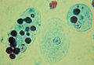
Trophozoites ofEntamoeba histolyticawith ingested erythrocytes

- 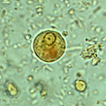
Immature Entamoeba histolytica cyst (mature cysts have 4 nuclei)

- 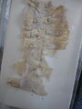
Amoebic Ulcer Intestine caused by Entamoeba histolytica

How Can I Prevent Amebiasis?
Proper sanitation is the key to avoiding amebiasis:
- Thoroughly wash hands with soap and water after using the bathroom and before handling food.
- Thoroughly wash fruits and vegetables before eating.
- Avoid eating fruits or vegetables unless you wash and peel them yourself.
- Stick to bottled water and soft drinks.
- If you must drink water, boil it, or treat it with iodine.
- Avoid ice cubes or fountain drinks.
- Avoid milk, cheese, or other unpasteurized dairy products.
- Avoid food sold by street vendors.

